

**KABARAK UNIVERSITY**

**SCHOOL OF BUSINESS AND ECONOMICS**

**DEPARTMENT OF COMMERCE**

**FINAL PROJECT REPORT:**

**INTEGRATING UNIVERSITY ENQUIRY CHATBOT ON A UNIVERSITY WEBSITE**

**A PROJECT REPORT SUBMITTED TO THE SCHOOL OF SCIENCE, ENGINEERING AND TECHNOLOGY IN PARTIAL FULFILLMENT OF THE REQUIREMENT FOR THE AWARD OF DEGREE OF BACHELOR OF COMMERCE IN BUSINESS INFORMATION TECHNOLOGY**

Submitted On:

**November 26, 2021**

# DECLARATION

I hereby declare that this project is my original work, and it has not been presented for the award of a degree in Kabarak University or any other learning institution and no part of this project has been copied for academic credit:

Signature: ______________________ Date: ______________________

Name: **Kelvin Njenga**  Reg No: **BBIT/MG/0908/05/18**

**Declaration by the Supervisor**

This research project has been submitted for examination with my approval as the university supervisor:

Signature: ________________________ Date: _______________________

Name: **MR. Dismas Ombuya**

lecturer, School of Science, Engineering and Technology

Kabarak University

# DEDICATION

I dedicate this project to my family, guardians, lecturer, friends and my fellow classmates for their continuous support, prayers and encouragement during this journey at Kabarak University.

# 

# ACKNOWLEDGEMENT

I sincerely recognize and acknowledge all the parties involved in numerous ways and their contribution to ensure the successful completion of this research proposal. First, I thank the almighty God for the good health and life He has bestowed upon me to pursue this course, I appreciate the support and guidance of our Supervisor Mr. Dismas Ombuya and my fellow classmates throughout this short period, and lastly to the entire management of Kabarak University for giving me an opportunity to pursue this degree in this great institution.

Table of Contents

DECLARATION ii

DEDICATION iii

ACKNOWLEDGEMENT iv

ABSTRACT ix

CHAPTER ONE: 1

INTRODUCTION 1

**1.1** **Background of the study** 1

**1.2 Statement of the problem.** 2

**1.3 Objectives** 3

**1.3.1 Main Objective** 3

**1.3.2 Specific Objectives** 3

**1.4 Proposed System** 3

**1.5 Justification of the study** 3

**1.6 Significance of the study** 4

**1.7 Scope and limitations of the study** 4

**1.7.1 Scope** 4

**1.7.2 Limitations** 4

**1.8 Research Questions** 4

CHAPTER TWO: 6

LITERATURE REVIEW 6

**2.1 Introduction** 6

**2.2 Brief History of AI chatbots** 6

**2.2.1 ELIZA** 7

**2.3 Benefits of University Enquiry chatbots** 7

**2.4 Features of university enquiry chatbots** 8

**2.5 Design Framework** 9

**2.6 Trends** 10

**2.7 Conclusion** 10

CHAPTER THREE: 11

RESEARCH METHODOLOGY 11

**3.1 Introduction** 11

**3.2 System Development Methodology** 11

**3.3 Target Population** 13

**3.4 Sampling Method Technique** 13

**3.5 Data Collection** 13

**3.5.1 Interviews** 14

**3.5.2 Questionnaires** 15

**3.6 Ethical Considerations** 17

CHAPTER FOUR: 18

SYSTEM ANALYSIS AND DESIGN 18

**4.1 Introduction** 18

**4.2 Context Diagram** 19

**4.3. DFD Diagram** 20

CHAPTER FIVE: 21

SYSTEM IMPLEMENTATION AND TESTING 21

**5.1 Introduction** 21

**5.2 Hardware and Software Requirements** 21

**5.2.1 Hardware Requirements** 21

**5.2.2 Software Requirements** 21

**5.3 Programming Language Used** 22

**5.3.1 Steps followed** 22

**5.4 Samples of Code used** 22

**5.5 Project Screenshots** 23

CHAPTER SIX: 25

CONCLUSION AND RECOMMENDATIONS 25

**6.1 Introduction** 25

**6.2 Achievements** 25

**6.3 Conclusion** 25

**6.4 Recommendations** 25

References 26

APPENDIX I: BUDGET 27

APPENDIX III: GANTT CHART 28

**LIST OF FIGURES**

Figure 1 sample conversation with ELIZA (file from Wikimedia commons) 7

Figure 2 how the AI chatbot works 9

Figure 3 Prototyping model 12

Figure 4 System Design 18

Figure 5 Context Diagram 19

Figure 6 Level 1 DFD 20

Figure 7 Hardware Requirements 21

Figure 8 Software Requirements 22

Figure 9 HTML sample code- University website UI 22

Figure 10 Intents.json sample code 23

Figure 11 Chatbot UI demo 1 23

Figure 12 Zoomed in Chatbot UI-Friendly conversation demo 24

Figure 13 University Chatbot UI- Enquiry demo 24

Figure 14 Budget Estimations 27

Figure 15 GANTT Chart 28

# ABSTRACT

Often, people have a tendency to spend their time interacting with various chat boxes on the web, largely targeted to undertake a certain task or for amusement purposes (e.g., Spotify bots to search for a particular music and play it). A Chat bot is an AI computer software that can stimulate a conversation with the user using NLP via text to text or text to speech mechanism. The chatbots have embedded data that helps them recognize the user’s questions and give a solution to that. This proposal will focus on developing a chatbot using NLP that will be used by the students/users to get their queries responded to quickly within the university’s website. Most of the existing chatbots lack empathy and fail to accommodate anything that isn’t part of the scripts. The major concerns facing University enquiry were:

1. Unavailability of 24/7 customer support as the University operates from 8:00am to 5:00pm weekdays only
2. Monotony plus huge workload as the customer support would respond to similar FAQs
3. Travelling costs expenses as the user would have to travel to the University to physically enquire about admission and courses offered

To solve this problem the chatbot will extend the implementation of current chatbots by adding sentiment analysis and active learning to correctly understand the user’s questions, make friendly conversations, offer 24/7 accessibility among other benefits. The chatbot will also use Machine learning and Data training algorithms to answer questions more intelligently.

**Keywords: Algorithms, FAQs, NLP, Machine Learning, Data training, chat bots**

# CHAPTER ONE:

# INTRODUCTION

This chapter consists the background of the study, the problem statement and the research question, the focus and objectives of the study, the significance of the study, the delineation of the field of study and the research methodology to be used to probe the problem.

## **Background of the study**

In recent years, AI has promised to revolutionize both the teaching and learning sectors as some prominent universities have integrated chatbots to their websites, and other applications to offer answers to questions that are asked every year as a new batch of students are admitted. The key to understanding how a chatbot can benefit a learning institution lies in the understanding what sets your target audience unique. Students are concerned a lot at every stage with their academic lives, making important decisions which will affect their future life. These students require knowing various types of information regarding a university before enrolling and during their academic stay at the learning institution. Such information as fees structure, location, degree offered and other logistics preferences usually require the student or Parent to visit the university and enquire physically or use different university websites. Students want to be sure that they chose the best university for their academic interests, their budget and other personal preferences, while still keeping in mind that they have unlimited university websites to consider.

let’s envision a KCSE graduate, who has performed well in Math and business studies and is looking to pursue a bachelor’s degree in commerce, but he/she is still unsure about the exact course that he/she intends on specializing in. they can visit the University website as part of their research, glance through all the courses offered by the university, and browse to the FAQs section. But they’ve probably done that on all other university websites they’ve visited.

As an alternative, the university could take a different path and help the student feel more relaxed on the university website. The university can leverage on integrating the chatbot to the website, the AI chatbot will greet the user, ask him/her about his/her education background, and send him details of the finance programs that he/she is eligible for via email.

Apart from generating obvious leads for the university website, this kind of personalized live support will benefit the university in making a positive impression on the potential applicants. With the right chatbot development and other direct factors, the university can expect an increase on the number of student admissions and registration.

## **1.2 Statement of the problem.**

The student, has limited information and customer support as the enquiry process is time-consuming and at the same time it is limited to working hours i.e., 8:00am to 5:00pm. The University website does not offer 24/7 live support service in accessing information which is crucial to the user for decision making practices such as choosing a course. Based on an article published by Forbes “*After one semester of Wilhelm’s nudges, Bethel’s retention rate increased 4%, and 85% of the students who used the bot rated it very favorably. On average over 95% of students offered the program, opt into it. One reason the uptake was so high is that students were reassured that the only people who saw their responses were institutional staff whose job was to help students succeed. Students were also informed that they could opt out simply by texting “STOP” whenever they wanted”.* Many students depend on the University admin to receive help concerning university enrollment issues, knowing the fees payment deadline, events that will happen within the academic year, results etc. majority of the students rarely read their emails as most of the information is not intended for them. The student will need an AI system which uses advanced decision making and machine learning to not only resolve these problems but also customize the process as per the request of the user while also reducing the number of inputs by the user.

## **1.3 Objectives**

### **1.3.1 Main Objective**

The main objective is to develop a University enquiry chatbot that reduces the burden on any institution during university admission enquiry i.e., that allows the students/user to easily enquire about joining the university based on his/her past performance and budget.

### **1.3.2 Specific Objectives**

1. To identify benefits of the university enquiry bot to its users who are the students.
2. To investigate and examine the necessary features of the chatbot system.
3. To identify upcoming trends which focus on implementing chatbot systems on websites.

## **1.4 Proposed System**

University enquiry chatbot will be built using AI algorithms that will analyze and understand the student’s/user’s query and provide feedback. The bot will be deployed on a university website where the user will be able to access it for chatting with the AI. The AI will be able to match keywords from its knowledge base in some cases to provide answers, if the user finds the feedback to be irrelevant, he/she can flag it as irrelevant and the instance of the invalid answer will be sent to the admin so that he can update the bot. the AI chatbot system will be integrated to a sample university website using Azure tools, cognitive services and Mongo Db to store students’ queries.

## **1.5 Justification of the study**

The AI chatbot keeps the student/learner engaged as he/she glances through the university website. It even reduces the university admin load while facilitating the user to make well informed decisions which are pivotal in shaping his/her future. As per statistical report submitted by HubSpot*, “approximately 21% of the customers believe that chatbots are the best and easiest way to initiate a conversation with any business”*

Students prefer social media channels to communicate, find solutions, share information etc. just imagine using such a platform (AI chatbot) that connects the lecturers and students in information sharing, messaging etc. only that it is embedded on the website. The students/users can also visit the university website and ask queries related to the institution, and get answers instantly. The chatbot will enable the student/users to get the right information at the right time, as the chatbot automates repetitive tasks, and offers answers nearly instant replies to queries being asked.

## **1.6 Significance of the study**

The significance of using university enquiry AI chatbot is that it offers 24/7 availability within 365 days a year, where users can freely converse with the chatbot at ease. The project will enable the University to reduce time taken on doing repetitive tasks.

## **1.7 Scope and limitations of the study**

### **1.7.1 Scope**

This chatbot system has been integrated to a sample website and it will target the university students around Kabarak. The chatbot will also utilize data.pth to store the intents data and process the students’ queries.

### **1.7.2 Limitations**

1. The chatbot only answers limited questions and cannot perform outside the code
2. The chatbot has similar answers for multiple queries i.e., if the user queries a question that the bot is not programmed to do it will output the same apology which is quite irritating to hear.
3. The chatbot has zero research skills and it has a low memory for remembering things
4. The chatbot can’t make decisions on its own it is only a guide to the student who wishes to enquire about joining the university.
5. The chatbot does not retain the users/students as they do not relate to the students’ feelings.
6. The chatbot requires internet connectivity so that the student can access it and use it.

## **1.8 Research Questions**

1. what code or implementation method has been used in existing chatbots?
2. How is the user experience like, of the existing chatbots?
3. What can be done to make the university chatbot more efficient?

# CHAPTER TWO:

# LITERATURE REVIEW

## **2.1 Introduction**

A chatbot is an essential tool for millennials in the 21st century since they make websites more interactive, easy and satisfying to use. People who have recently finished high school face a lot of challenges while looking for universities to enroll not knowing the courses, fee’s structure etc. these students need to be sure that the course that they are intending to do fits their academic interests, their budget and that they are guaranteed support in areas where they may experience difficulties. On the other side if the university receives a bulk of queries, having a chatbot integrated to the website takes off the load from support team. The university bot will increase the response rate as compared to the human support team. Since millennials prefer chats over phone calls, they will find the chatbot attractive as it automates repetitive tasks and it can be used in marketing the university.

A user’s query can be solved at any particular time of the day i.e., consider amazon shopping app, when the customer purchases a product, he/she has no idea of returning the product. In order for the customer to return the product he/she has to call the customer support at amazon and this takes time before the customer support picks the call. However, amazon has integrated a chatbot to answer simple queries to customers

## **2.2 Brief History of AI chatbots**

University enquiry bots are a new phenomenon in the country, majority of folks are still looking for universities and learning institutions in the conventional manner. The use of AI bots in the marketing industry has been on an upward trajectory in the last decade, this created the perfect environment for AI chatbots to thrive. With the increase in internet connectivity in the country, mobile phones have become part of our day-to-day activities hence developers have realized an existing gap to create more effective chatbots. The first chatbot created was ELIZA which utilized NLP and paved way for the development of other advanced chatbots used in different sectors such as the marketing sector, finance sector, transport sector etc.

### **2.2.1 ELIZA**

This was the first bot to be created between 1964 to 1966 by Joseph Weizenbaum which utilized Natural language processing. The idea was to read the user’s input and search for certain keywords then produce output based on the specified rules. If the certain keywords were not found by ELIZA it would try to get more information from the user to keep the conversation going based on the specified constraints of its scripts. The above image shows how ELIZA would work

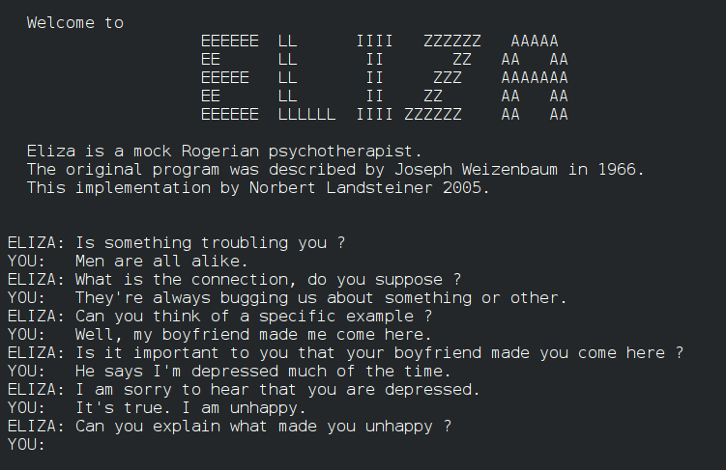

Figure 1 sample conversation with ELIZA (file from Wikimedia commons)

## **2.3 Benefits of University Enquiry chatbots**

**2.3.1 User-friendly experiences**

The chatbot system maintains an easy-to-use UI across all devices, operating Systems

**2.3.2 Greater Engagement**

Chatbots ensure constant communication between the admin and the students. it also helps the student to get answers quickly and efficiently.

**2.3.3 improves query handling system**

The university chatbot is more efficient in dealing with students, and performing repetitive tasks just by querying in your questions.

**2.3.4 Access data while on the go**

Usually, students lack the time and drive to check their emails or travel to the administration to receive help as they feel inconvenienced with time and bus fares. The integration of the chatbot allows the students to glance or receive live support at the comfort of their homes.

**2.3.5 Extended market reach**

The university will be able to receive and collect information which is crucial in marketing the university’s courses as they save the logs of the most searched course etc.

## **2.4 Features of university enquiry chatbots**

**2.4.1 Interactions**

The chatbot chats with the user, informs him/her if the answer is not available.

**2.4.2 Feedback**

The chatbot system enables a user to leave the feedback inform of a text.

**2.4.3 Searching**

The chatbot system enables the user to search for information about admissions, fees etc.

**2.4.4 Ethics**

The chatbot does not use any user’s data for malicious purposes i.e., chatbot does not store or process any information concerning the user without his/her consent.

**2.4.5 Easy omnichannel deployment**

The chatbot system is cross platform i.e., runs on different operating systems

### **2.5 Design Framework**

From the data collected by the University website, the chatbot is created in such a way that it analyzes student queries/inputs then it identifies the intent and entities of the input to build and generate a response to the user using text. The chatbot creates replies to the user queries using NLP and sentiment analysis to provide answers to the user which have empathy.

For example; if the user wishes to know the operating hours of the university, the intent is office hours and entity name will be the faculty name.

Before coding the University enquiry chatbot, I had glanced and looked at amazing chatbots such as Alexa, google assistant in order to understand the requirements of a chatbot.

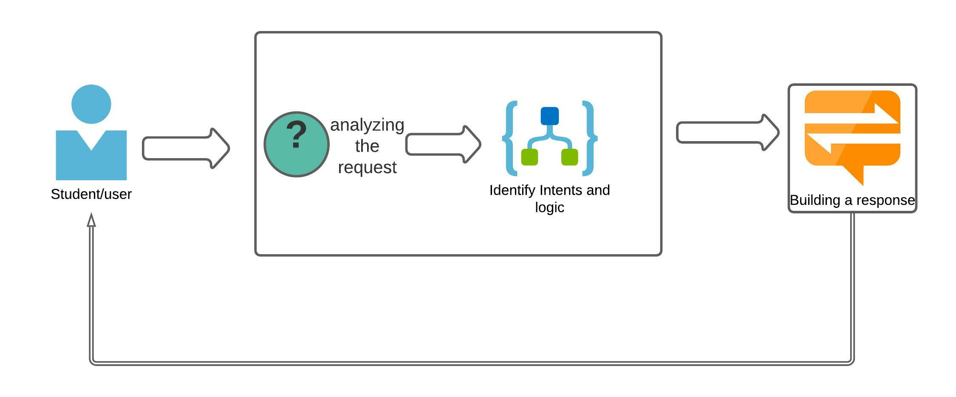

Figure 2 how the AI chatbot works

## **2.6 Trends**

The corona pandemic has accelerated the digitization of university websites even further than was expected. Developer all over the world are coming up with different ways to create amazing chatbots for industries, they include:

1. Innovative chatbot experience which may include pop up experience that allows users to browse listings like in online shopping experience. Also, effective display of data and content on your mobile user interface is important for a sound user experience.
2. Motion and location sensing will be an important feature for applications. Smartphones have location sensor capabilities which use positioning data to provide location data.

## **2.7 Conclusion**

Based on my findings as articulated in this literature review, I conclude my research believing that the system meets the objectives above i.e. developed a data.pth where all related data will be stored and developed an algorithm app.py that is used to identify queries and provide answers to the user then integrated the bot to a university website.

# CHAPTER THREE:

# RESEARCH METHODOLOGY

## **3.1 Introduction**

In this chapter, system development methodology, all the tools and methodologies used in data collection, feasibility study requirements and the general flow of how the application will work, are clearly elaborated.

## **3.2 System Development Methodology**

Prototyping model was used to develop the university ai chatbot system. In the prototyping methodology, the design focus was to produce an early model of the new system, software, or application. The prototype does not have full functionality nor has it been thoroughly tested, but it will give the users a sense of what’s to come. Then, feedback will be gathered and implemented throughout the rest of the SDLC phases.

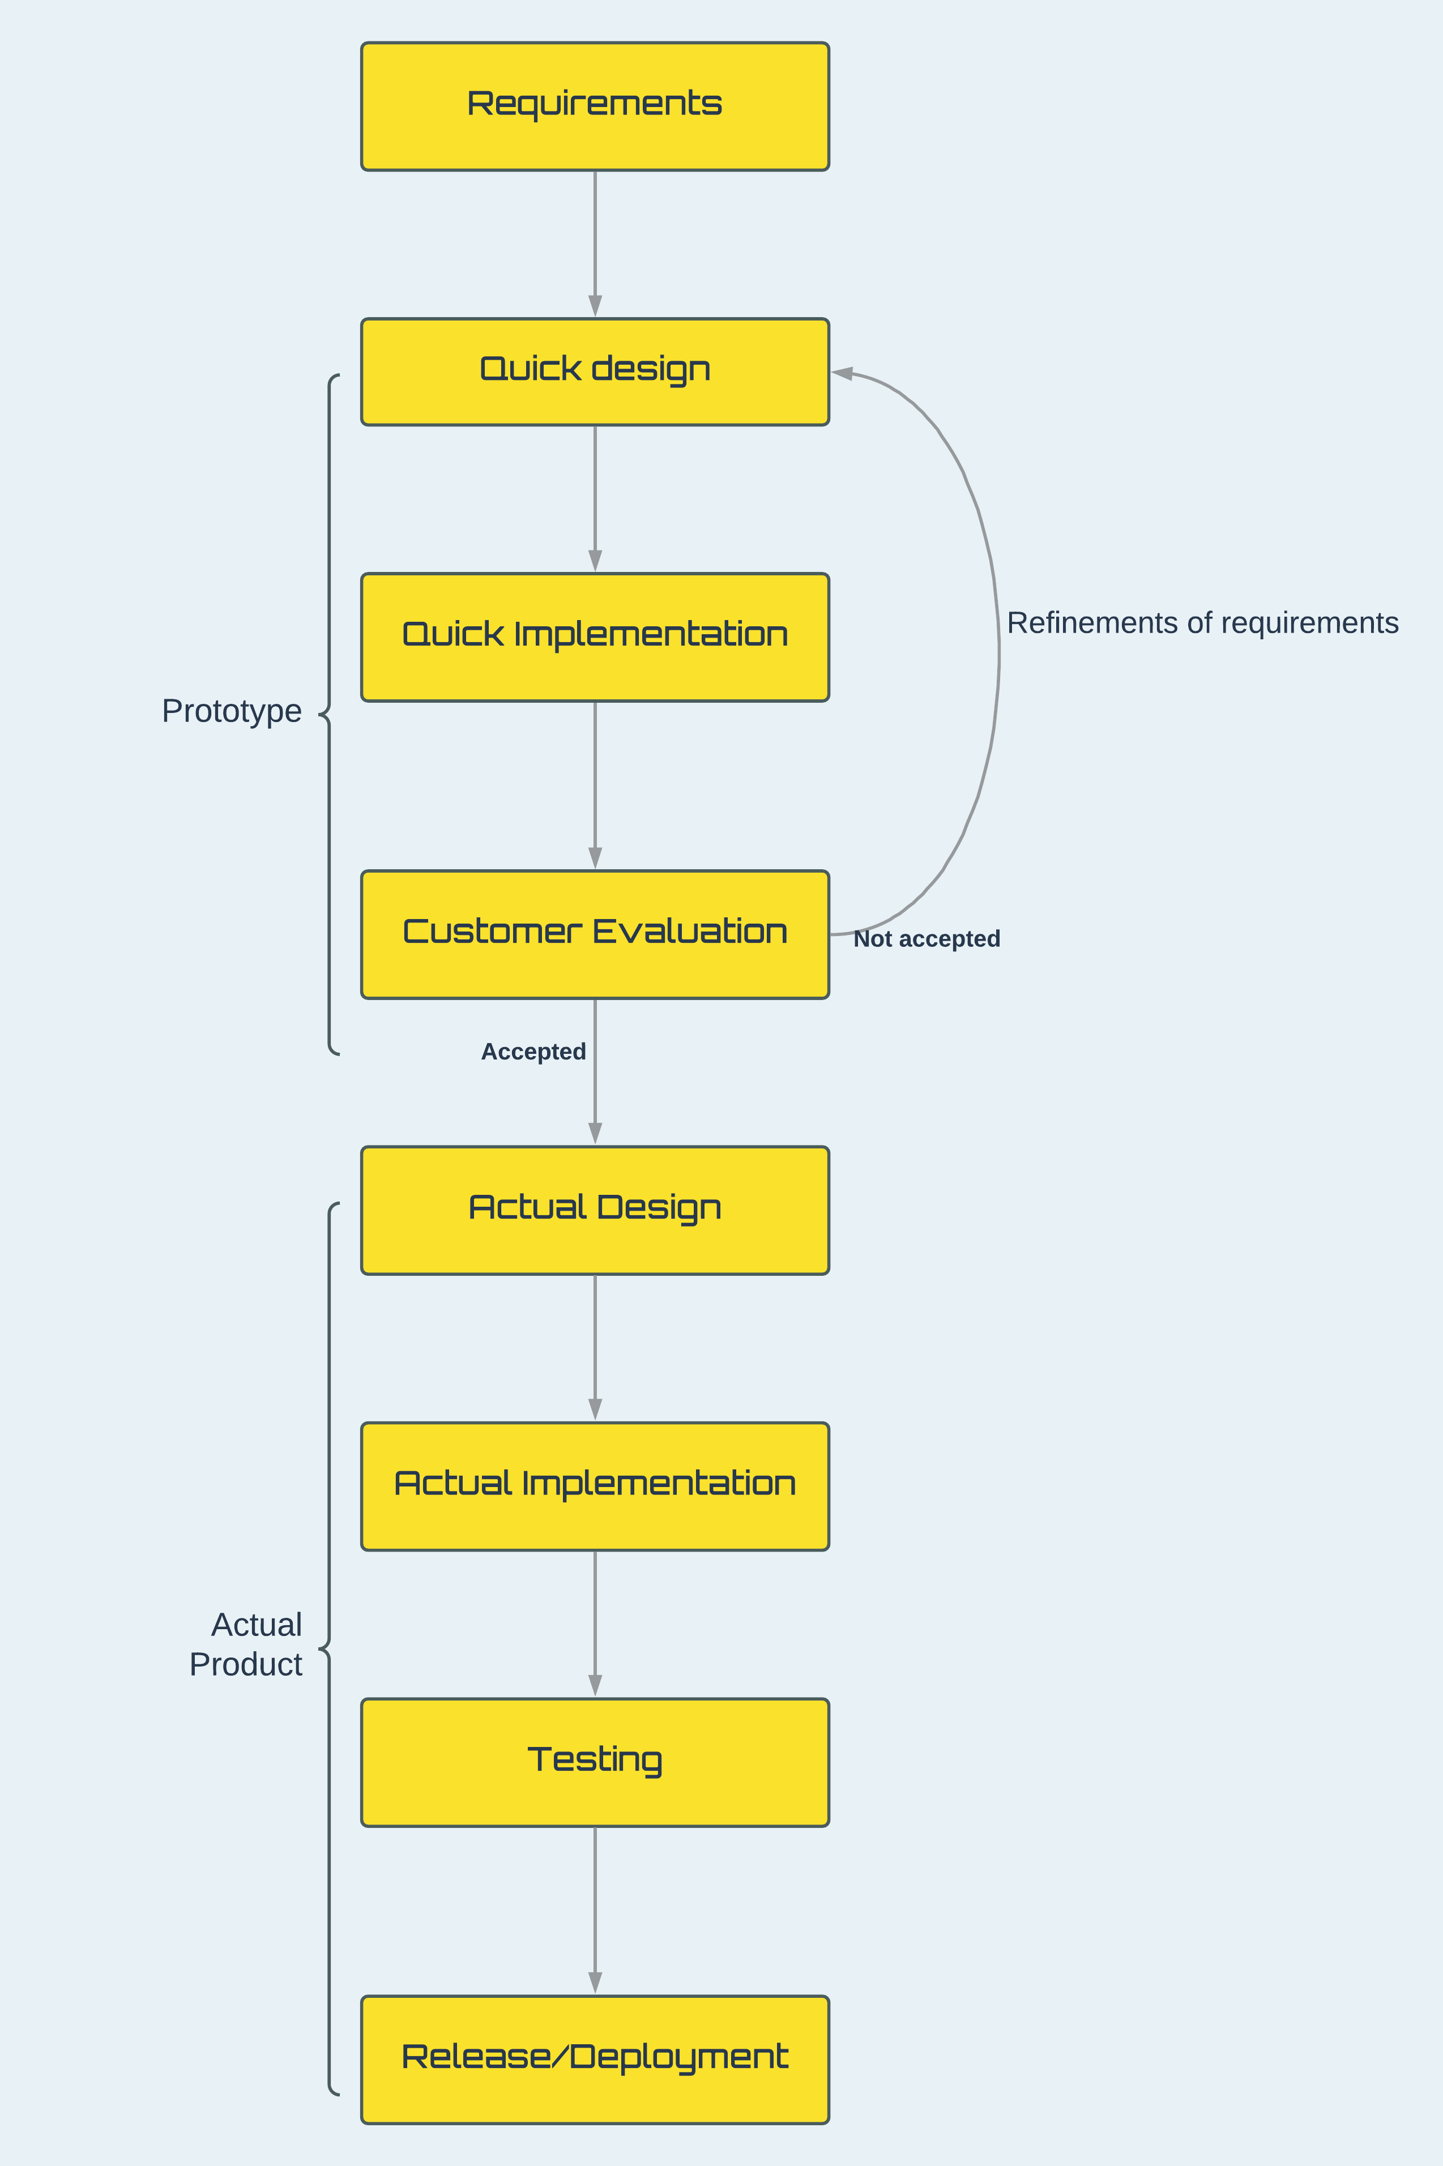

Figure 3 Prototyping model

**Advantages of Prototyping Model**

1. Developers will learn from the customers
2. The customer/user will have the opportunity to review the system
3. Useful for systems that keep on changing
4. Offers room for revision and tweaks

**Disadvantages of Prototyping Model**

1. Process may continue forever i.e., “scope creep”
2. Consumes a lot of time

Despite the disadvantages I used the Prototyping model to develop this system as it requires the Customer feedbacks for building, testing and improving the university enquiry chatbot.

## **3.3 Target Population**

The proposed project targets mainly university students and potential students who are enquiring on joining the university.

## **3.4 Sampling Method Technique**

Purposive sampling technique was used where I selected a subset of participants from the target population of about 30 students. This sampling technique was less time consuming, required no list and can produce better results.

## **3.5 Data Collection**

Data collection is defined as the procedure of collecting, measuring and analyzing accurate insights for research using standard validated techniques. Data collection is the primary and most important step for research. The most critical objective of data collection is ensuring that information-rich and reliable data is collected for statistical analysis so that data-driven decisions can be made for research.

There are various data collection methods used but in this chatbot system, I decided to pick the following methods to collect information:

1. Interviews
2. Questionnaires

### **3.5.1 Interviews**

The interview method collects data from a small group of subjects on a broad range of topics. It involves presentation of oral-verbal stimuli and reply in terms of oral-verbal responses.

There consists of three types of interviews:

1. **Structured**, which is also known as standardized interview. It allows very little or no scope of prompting the participants to obtain and analyze results and is significantly quantitative in its approach.
2. **Semi structured**, which offers a considerable amount of leeway to the researcher to probe the respondents along with maintaining basic interview structure.
3. **Unstructured**, also known as in-depth interviews, usually described as conversations held with a purpose in mind to gather data about the research study. These interviews have the least number of questions as they lean more towards a normal conversation but with an underlying subject.

**Advantages of Interviews**

1. Sufficient information: Sufficient information can be collected through the interview process. Because the interviewer can ask any question to the interviewee.
2. Time saving: Interview can help to save time to select the best suitable candidate. Within a very short time communication can be accomplished with the interview.
3. Increasing knowledge: Any interview increases the knowledge of both the interviewer and the interviewee. They can interchange their views and ideas.
4. Less costly: It is less costly than other process of communication. It is very simple, prompt and low-cost method of communication.
5. Collection of primary information: Interview can help to collect the fresh, new and primary information as needed.

**Disadvantages of Interviews**

1. No record: In the case of the interview some confusion may be arisen in the future as, there is no evidence actually that have been discussed at interview.
2. Inefficiency of the interviewer: Interview is a systematic process of data collection. The success of an interview depends on the efficiency of the interviewer. This inefficiency of an interviewer can lead to misleading results.
3. Incomplete process: Suitable candidate cannot be selected by interview only. The written test is more important than the interview.

### **3.5.2 Questionnaires**

A questionnaire consists of a formalized set of questions either printed or written in a structured form. The questionnaire is designed to collect information on some subject or subjects from one or more respondents. The respondents are expected to read and understand the questions and give replies or answers to the series of questions in the space meant for the purpose in the questionnaire itself. The respondents have to answer the questions on their own. Questionnaires contain short closed-ended questions (multiple choice) or broad open-ended questions.

**Data Collection Procedure while using questionnaires**

Data collection procedure involves the use of a questionnaire for quantitative research and use of interviews for qualitative research.

**Quantitative Survey of the Research to be conducted**

Data collection procedure during the quantitative survey involves the use of a short-self-administered questionnaire to sample population. I will deliver the questionnaires to the respondents as the researcher. The delivery of the questionnaire will be accompanied by a letter explaining the purpose of the research and request that the questionnaire be completed.

**Qualitative Survey of the Research to be conducted**

The qualitative survey involves the use of face-to-face interviews. It will directly involve the implementation of the university enquiry chatbot. This will seek to explore whether they will be ready to embrace a new university enquiry chatbot system. The respondents will be given enough time to prepare so that they would voluntarily give the required information without pressure.

As the researcher I will prepare myself adequately prior to the interview to ensure the success of the process. Each interviewee will be briefed on the information concerning the goals of the study and the purpose of conducting the interview. Each interview will be expected to last between 5 to 10 minutes.

**Preferred methodology of collecting data**

I used questionnaires because: they ensured high response rate as the questionnaires were distributed to the respondents to complete, I personally as the researcher collected them, this method required less time and energy to administer, there was also less opportunity for bias as they were presented in a consistent manner and also offered anonymity because subjects ‘names were not required on the completed questionnaires.

Secondly, as the researcher I wanted to get the opinion of a larger population of middle-class earners or university students, quantitative methods through questionnaires were appropriate. The quantitative method helped to obtain responses from a larger sample from the population of interest and this also gave the respondents ample time to respond.

## **3.6 Ethical Considerations**

The University enquiry chatbot ensured anonymity since the identity of the participant will remain unknown as he/she was not required to enter any personal details in the formulation of a questionnaire. However, respondents participated on the basis of informed consent.

Voluntary response from the participant was also available as the participant could withdraw from the research work at any particular stage and time.

The questionnaires and interviews were driven with the motive of only assessing relevant components such as what functionalities need to be added to the system while still maintaining confidentiality of the highest level.

The University enquiry chatbot system ensured that the questionaries did not use any offensive, discriminatory or unacceptable language while formulating and implementing the system.

# CHAPTER FOUR:

# SYSTEM ANALYSIS AND DESIGN

## **4.1 Introduction**

The system design of the University Enquiry Chatbot consists of multiple technologies. The system makes use of HTML and CSS for frontend, JavaScript and Python for Backend and data.pth to store the trained intents from the intents.json file.

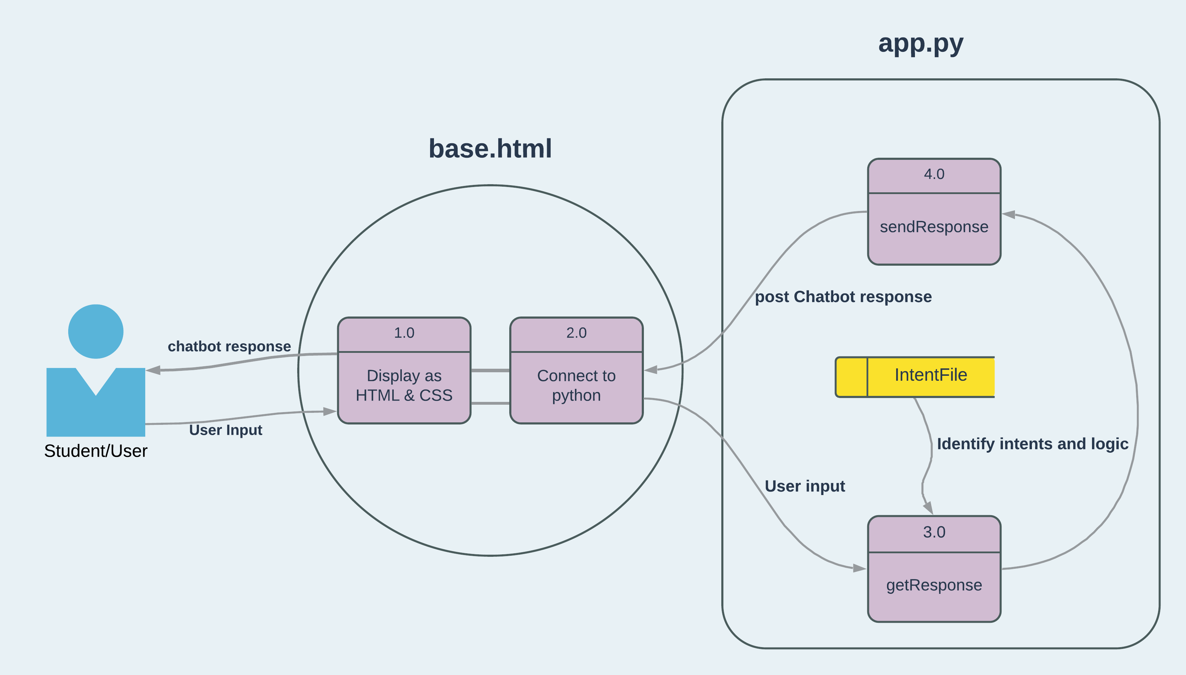

Figure System Design

## **4.2 Context Diagram**

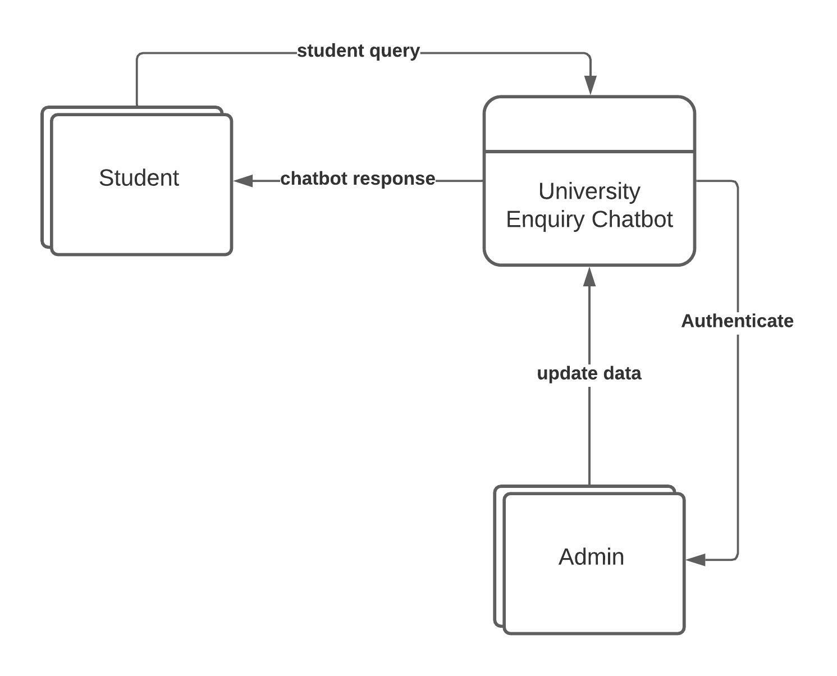

Figure Context Diagram

## **4.3. DFD Diagram**

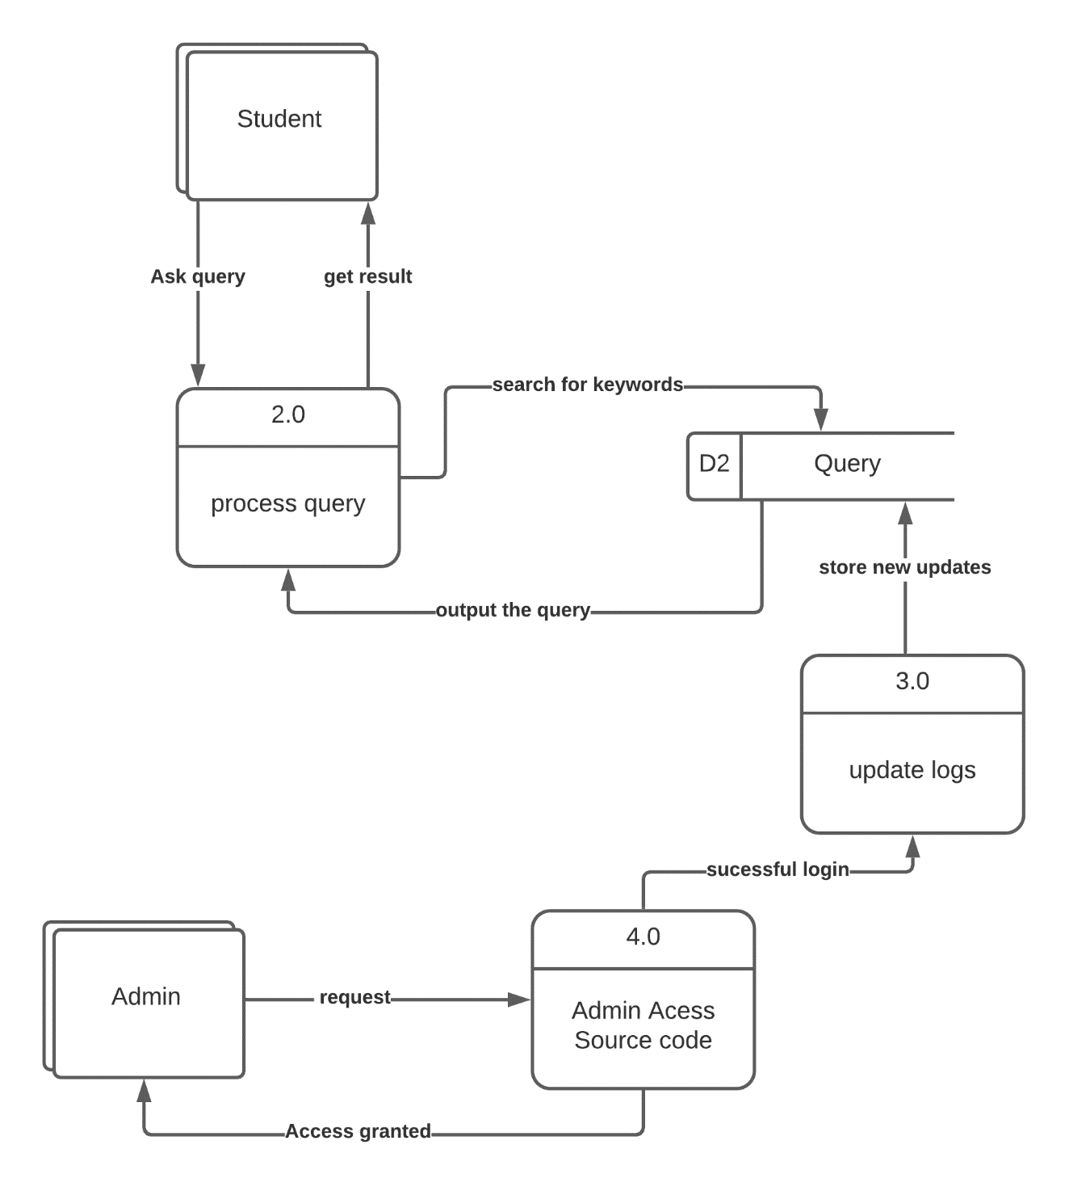

Figure Level 1 DFD

# CHAPTER FIVE:

# SYSTEM IMPLEMENTATION AND TESTING

## **5.1 Introduction**

In this section of the report, a step-by-step demonstration of how to set up the bot and website is explained

## **5.2 Hardware and Software Requirements**

### **5.2.1 Hardware Requirements**

The table below shows hardware components of the PC that the system should run on and function as required using the system.

|  |  |
| --- | --- |
| Hardware | Minimum System requirements |
| Processor | 1.8 GHZ processor speed, 64-bit |
| Memory | 2GB RAM |
| Disk space | 30MB |
| Connectivity | Wi-Fi |

Figure Hardware Requirements

### **5.2.2 Software Requirements**

The table below shows the minimum software requirements required for the system to run on a given Workstation or PC.

|  |  |
| --- | --- |
| Software | Minimum System requirements |
| Operating System | Windows 7 or later |
| Applications | Browsers e.g., Chrome, Microsoft Edge, Firefox |
| Run-time Environment | Anaconda  PyCharm IDE |

Figure Software Requirements

## **5.3 Programming Language Used**

In full development of the project I have used Json to create various intents, python to train the model on the intents.json file, html and CSS to create the User Interface, and JavaScript and python to create the backend of the System.

### **5.3.1 Steps followed**

1. Download PyCharm and install the necessary packages i.e., pandas, pytorch etc.
2. Run the train.py file in the terminal with the following command- python train.py
3. Run the app.py file in the terminal with the following command- python app.py
4. On the terminal click on the highlighted link -http://127.0.0.1:5000/
5. Click on the Chat icon and enter your queries
6. To quit press -Ctrl + C to quit

## **5.4 Samples of Code used**

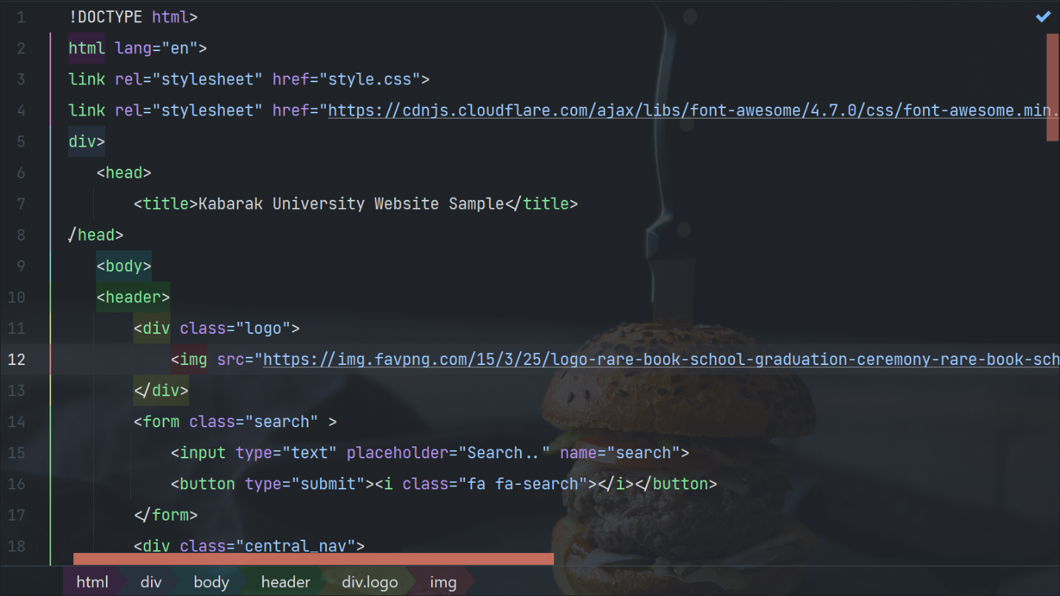

Figure HTML sample code- University website UI

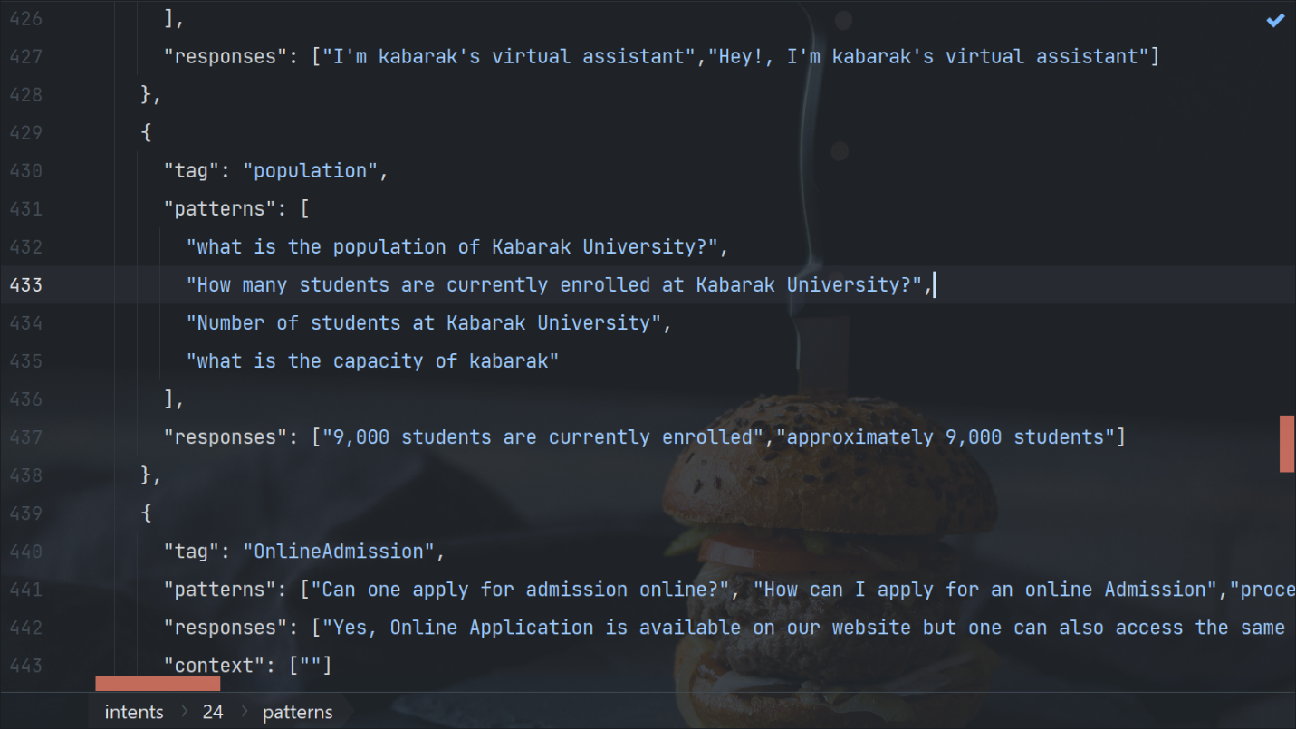

Figure Intents.json sample code

## **5.5 Project Screenshots**

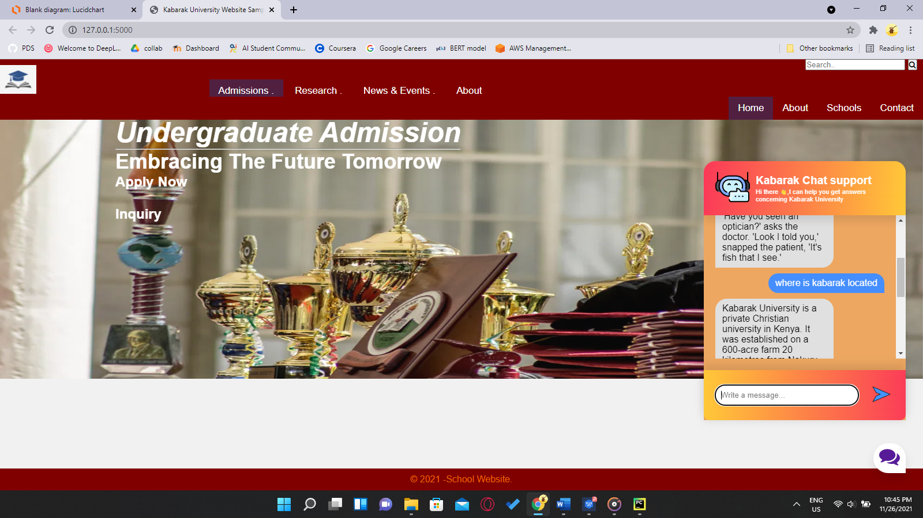

Figure Chatbot UI demo 1

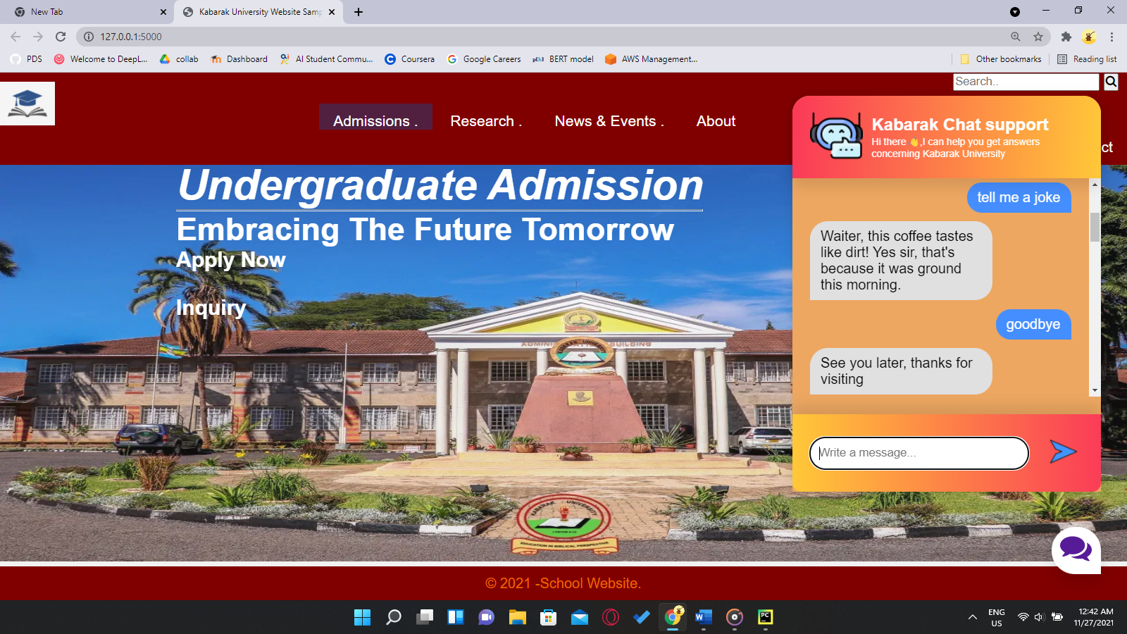

Figure Zoomed in Chatbot UI-Friendly conversation demo

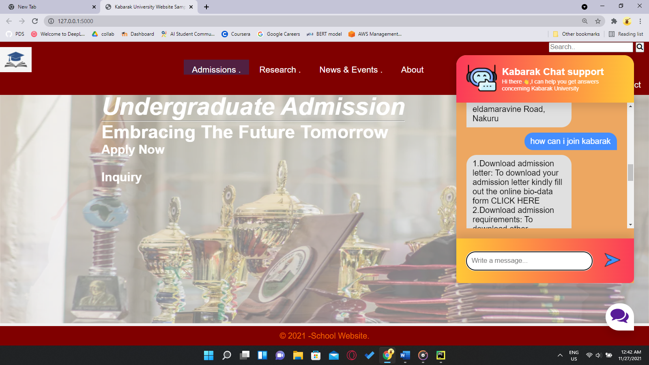

Figure University Chatbot UI- Enquiry demo

# CHAPTER SIX:

# CONCLUSION AND RECOMMENDATIONS

## **6.1 Introduction**

This chapter marks the end of the explanation on the working of University Enquiry Chatbot. It highlights the achievements as well as the conclusions and recommendations.

## **6.2 Achievements**

The chatbot clearly improves the response rate compared to human support team

The chatbot is able to receive and send response to the user/student anytime

The chatbot is deployed and integrated on the university website where students can interact with it

## **6.3 Conclusion**

To conclude, the University enquiry chatbot is helpful in guiding students with correct and up-to-date information concerning the university. Students and potential students can get information at their fingertips rather than visiting the university offices. This improves efficiency by taking over tasks for which humans are not required to undertake. It is advantageous for international applicants for queries such as fee payment, location and academic matters

## **6.4 Recommendations**

To improve the current functionalities of the University Enquiry Chatbot, in the future, the scope of the chatbot can be increased by inserting data for all the Institutional departments, training the bot with varied data, testing it on live website, and based on that feedback inserting more training data to the bot.

Some of the features that can be added in the future include:

* Speech recognition that enables the user to query and receive a verbal response.
* Integration with multiple channels such as twitter, Facebook etc.
* Capability of the bot to perform analytics based on the user’s sentiment on which the bot can be retrained on human emotions so that empathy is added
* Integration with services such as course enrollment and password reset

# References

A. Storman. (2016). *5 Chatbot Challenges and How to Overcome Them.* Retrieved July 2021, from https://chatbotsmagazine.com/5-chatbotchallenges-and-how-to-overcome-them-caccc3a26d7c

Amazon Alexa - Build for Amazon Echo Devices. (2017). (Developer.amazon.com). Retrieved June 2020, from https://developer.amazon.com/alexa.

Expertsystem.com. (2018). Chatbot: What is Chatbot? Why are Chatbots Important? Retrieved from https://www.expertsystem.com/chatbot/.

G. Pilato, A. A. (2011). A Modular Architecture for Adaptive Chatbots,. *Proc. IEEE of 2011 Fifth IEEE International Conference on Semantic Computing (ICSC)*, (pp. 177-180). doi:10.1109/ICSC.2011.68

*How to Manage Customer Service Technology Innovation*. (2020, January 2). Retrieved from https://www.gartner.com/smarterwithgartner/27297-2/

Negnevitsky, M. (2005). Artificial Intelligence: A guide to intelligent systems. 2nd ed London: Pearsons.

Stanislav, O. (2019). How chatbots can be involved in the education process. *IEEE Conference Proceedings (IEEE Conf Proc).* *2019*, pp. 575-580. United States (USA): IEEE.

Unknown. (2019, April 1). *How Chatbots are Transforming Wall Street and Main Street Banks?* Retrieved from https://marutitech.com/chatbots-transforming-wall-street-main-street-banks/

# APPENDIX I: BUDGET

|  |  |  |  |
| --- | --- | --- | --- |
| **ITEM** | **DESCRIPTION** | **QUANTITY** | **PRICE** |
| PC workstation | Intel Core i7 Processor (2.1 GHz or more), RAM (4Gb or more,  500Gb Hard Disk | 1 | 60,000/= |
| Operating System | Windows 10 Pro | 1 | 14,500/= |
| Application | Notepad++ | 1 | Free/ Open Source |
| IDE (Integrated Development Environment) | PyCharm | 1 | Free/ Open Source |
| Internet | Safaricom Home Faiba | 1 | 3000/= |
| **TOTAL** |  |  | **77,500/=** |

Figure Budget Estimations

# APPENDIX III: GANTT CHART

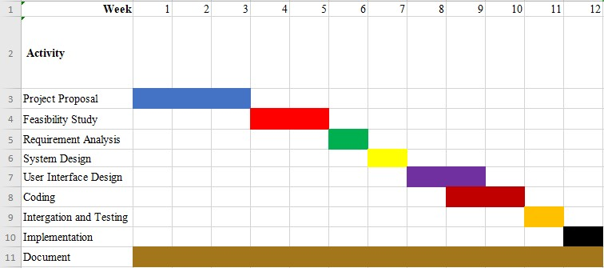

Figure GANTT Chart